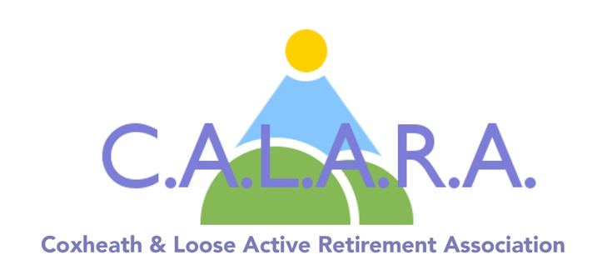

**What Are We?**

An active retirement association.

**Who Can Join?**

Any retired resident in the area over the age of 50.

**We are a non profit organisation affiliated to KENTARA – Kent Active Retirement Assoc.**

**MEMBERSHIP is £5.00 a year which includes monthly meetings with entertainment.**

**Weekly activities and outings etc. are charged at cost.**

  

**What Do We Offer?**

A way to meet new people through a range of activities, including:

Weekly:

Indoor Bowls, Arts & Craft, Exercise Classes, Cribbage and Whist

Plus: Holidays, Outings, Theatre Trips, Lunches,

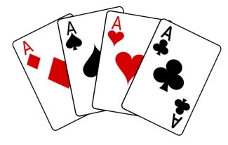

**When?**

Monthly meeting on the first Friday (Tea, biscuits, and entertainers.)

Weekly activities as above

**Where?**

Coxheath Village Hall,

Stockett Lane,

ME17 4PT

**Want to Know more?**

Please contact our membership Secretary –

Christine Coleman **01622 744041**

Or visit our website www.calara.org.uk